Stripe Payment Process Documentation
(For Healer Appointment Website)
Overview (How Payment Works)
Flow:
- User books an appointment
- User pays online via Stripe
- Money is held safely by Stripe
- After appointment completion → Healer gets paid
The Super Admin Roles in (THN)
- Owns the main Stripe account
- Sets commission percentage
- Manages refund rules
- Views all transactions in Stripe Dashboard

- 1 : How to Make Real Strip Account
• Go to 👉 https://stripe.com
  - Click Start now
  - Sign up with business email
Completed:
Step:1
- Business details
- Bank account
- Identity verification
Step:2
- Login to strip Dashboard
- Go to Settings → Connect
- Enable Express Accounts
- Save changes
Step:3
- Go to Developers Api Keys
Copy:
- Publishable Key
- Secret Key
- Send these keys securely to the (Abdul Rehman)

After that, the client will add the live Stripe keys in (THN). The developer will update the Stripe integration and add a new page in the Healer Dashboard called “Configure Payment,” where healers can register and securely add their cards to Stripe
Healer Payment Setup
- Healer registers on the website
- Healer opens Configure Payment Page
- Healer Stripe onboarding opens
- Healer:
  - Adds personal details
  - Adds bank account
- Stripe creates a Connected Account
- Healer can now receive payments

Connected to Stripe Requirement
- CNIC / Passport
- Bank account details
- Email address
- Phone number
- Address
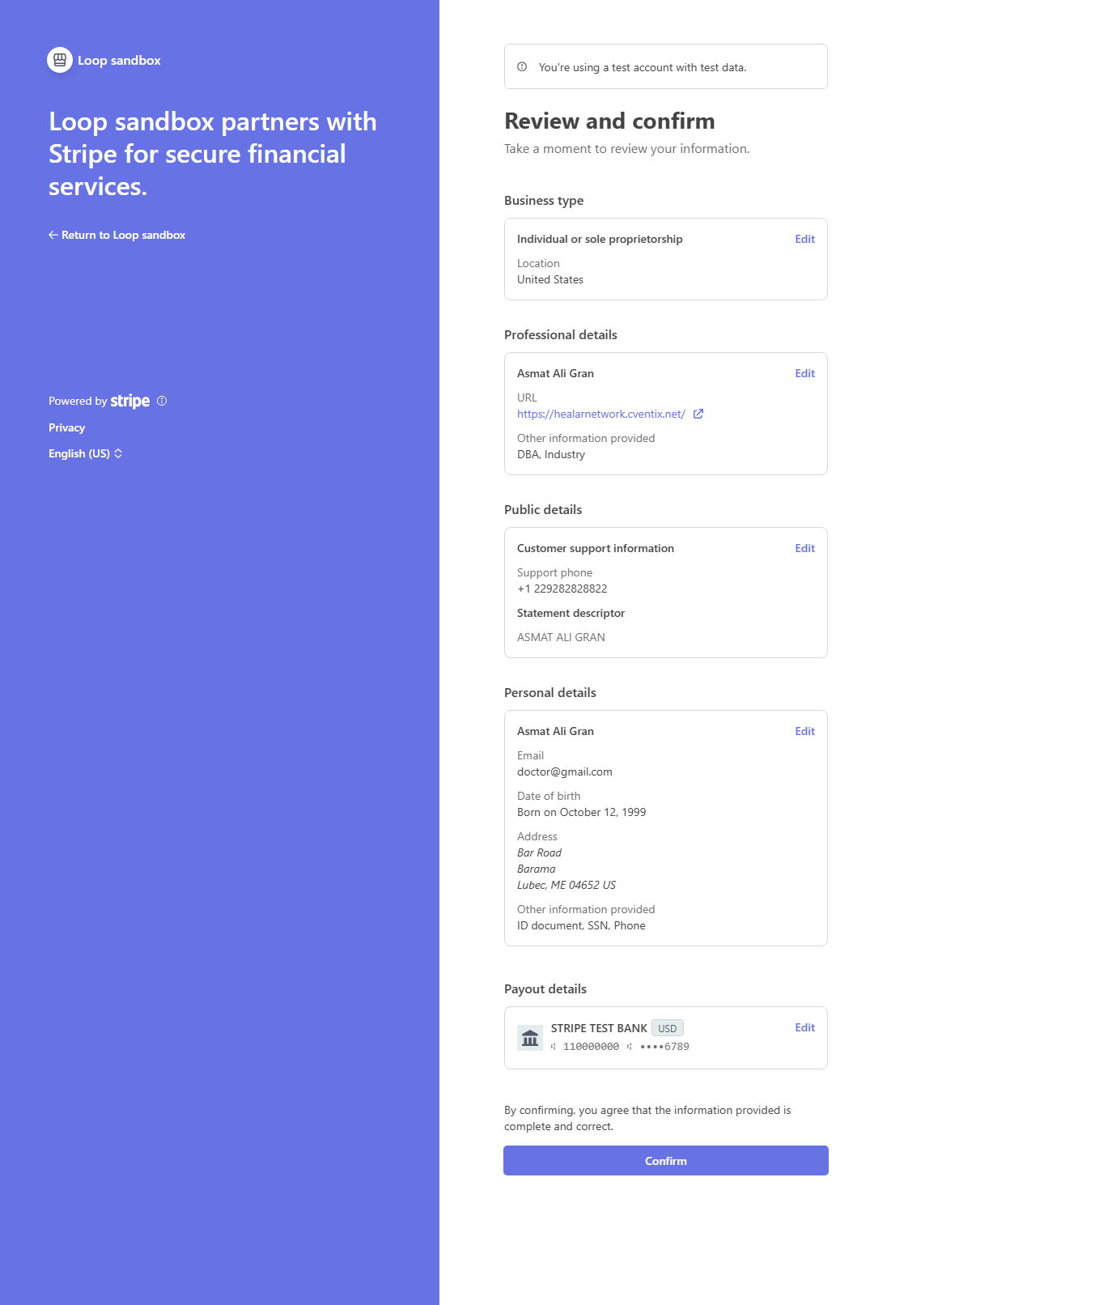
How to HTN Healer Dashboard when Healer Connect to Stripe
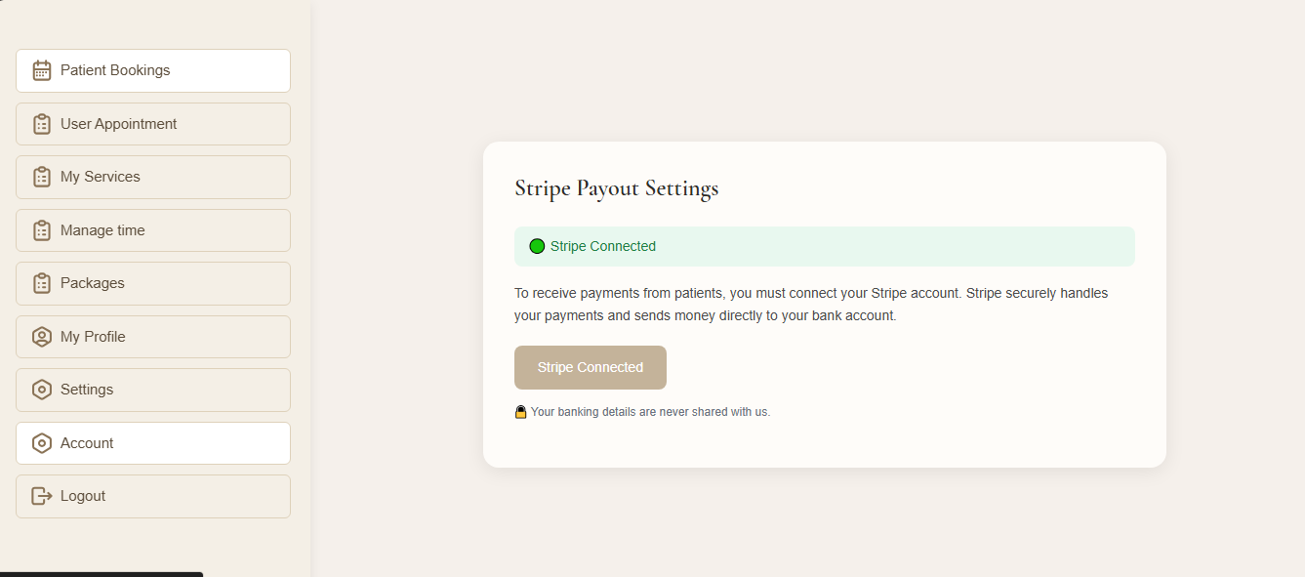
HTN Stripe Dashboard
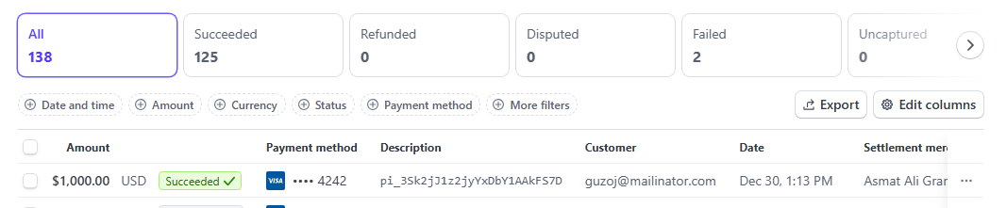

Healer Dashboard HTN Stripe Side
